➢➢ Explanation :
- Consider that a block of data of N bytes is present at source location. Now this block of N bytes is to be moved from source location to a destination location.
- Let the number of bytes N = 10.
- We will have to initialize this as count in the C register.
- We know that source address is in the HL register and destination address is in the DE register.
- Get the byte from source memory block and store the byte in the destination memory block.
- Transfer data byte by byte from source to destination block till all the bytes are transferred.
➢➢ Algorithm :
Step I : Initialize the register C with count.
Step II : Initialize HL and DE with source
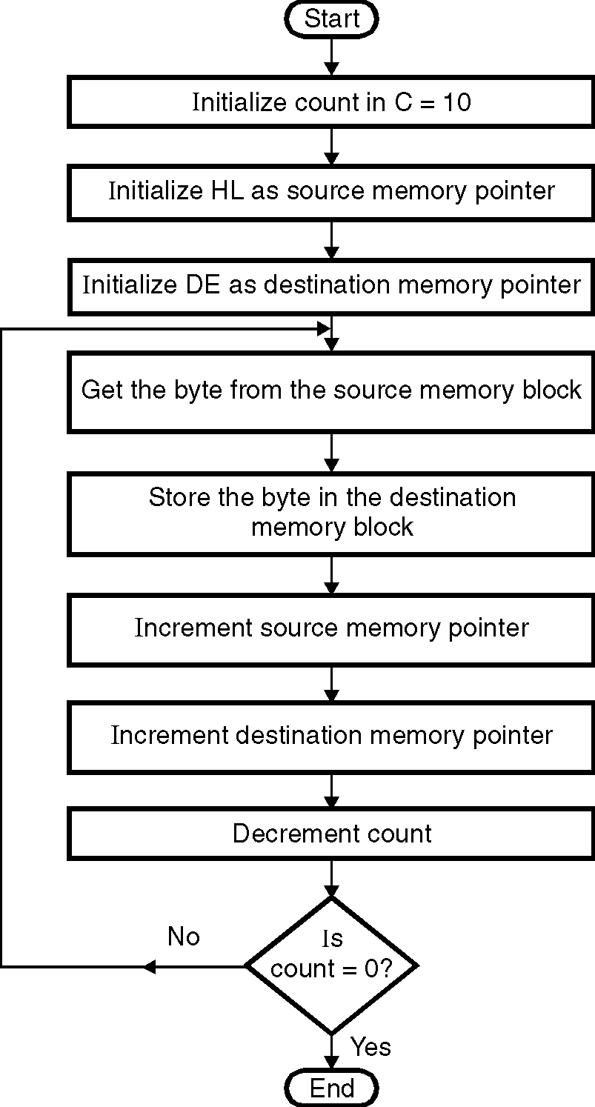
and destination address.
Step III : Get the byte from source memory block.
Step IV : Transfer the data to destination block.
Step V : Increment source memory pointer
Step VI : Increment destination memory pointer.
Step VII : Decrement Count.
Step VIII : Check for count in C,
if not zero goto step III
Step IX : Stop.
➢➢ Flowchart : Refer flowchart 20.
ØØ Program :
Instruction Comment
MVI C, 0AH ; Initialize counter
LXI H, D000H ; Initialize source
; memory pointer
LXI D, E000H ; Initialize destination
; memory pointer
BACK: MOV A, M ; Get byte from source
; memory block
STAX D ; Store byte in the
; destination
; memory block
INX H ; Increment source
; memory pointer
INX D ; Increment destination
; memory pointer
DCR C ; Decrement counter
JNZ BACK ; If counter ≠ 0 repeat Flowchart 20
HLT ; Terminate program execution

